AWS CICD with Jenkins

Topics
- Cloud Computing
- AWS Introduction
- Elastic Cloud Compute (EC2)
- Amazon Machine Image (AMI)
- Elastic Block Store (EBS)
- Security Group
- Simple Storage Service
- EC2 Scaling
- Continuous Integration

Continuous Integration
Use Case:
Robert and Ginni working on a project, coding and well tested individually however when they integrated it crashes and everything breaks. Code fails to compile and bugs so HOW TO integrate?
Issues due to this ->
- Difficult to resolve how long it will take to resolve.
  - May exceed budget
  - May exceed our schedule
Solution
CI - Integrate early and integrate often ( on every change)- everytime code is changes to repository it should be test out and build, compile and component interoperate correctly.

Continuous Integration Server
http://www.methodsandtools.com/tools/tools.php?hudson
Continuous Integration (CI) is a software development practice where members of a team integrate their work frequently, usually each person integrates at least daily - leading to multiple integrations per day. Each integration is verified by an automated build (including test) to detect integration errors as quickly as possible. Many teams find that this approach leads to significantly reduced integration problems and allows a team to develop cohesive software more rapidly."
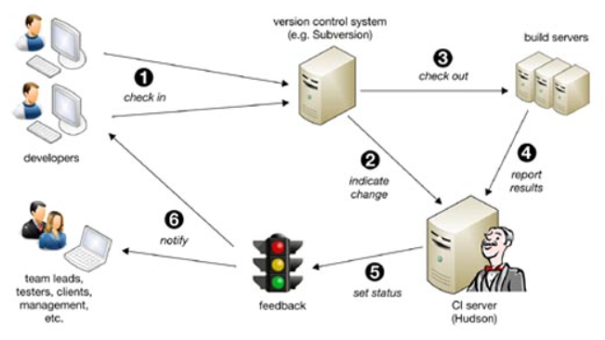
(1). Hudson polls this system regularly for changes, e.g. every minute
(2). If changes are indicated, the new code is checked out to build severs
(3) and a new build of your project is executed. The results are reported back to Hudson
(4) that will set the new status of the project
(5): stable, instable, or failed. Finally notifications are sent to developers and other stakeholders
(6), which will either fix any problems found or proceed implementing new features. This complete cycle typically does not exceed 15 minutes.

Benefits
- Developer might forgot to run tests
- It might take too long to run the tests
- We might need to test code in various environments
- Reports provides insight to team
  - Can track metrics like line coverage
    - Percentage of lines executed by program’s test
  - Can run all sort of utilities on our code
    - Checkstyle, findbugs….
- Can deploy automatically
  - Deploy a web project to staging server
  - Deploy latest stable build of a desktop application to web site for download

How to install Jenkins on AWS EC2
https://www.youtube.com/watch?v=jmm8DsosBqw

How to download and install Jenkins an aws ec2 linux.

How to access Jenkins from Browser

How to start and stop Jenkins

How to start Jenkins on different port

How to Uninstall Jenkins
Step 1 : Connect to your Linux machine
SetUp JAVA PATH
Set up Custom TCP port: 8080 in AWS Security Groups
Step 2: Update Packages
sudo yum update
Step 3 : Check Java is installed. If not install java
java -version
sudo yum install java-1.8.0
To check and select one out of multiple java versions available
sudo /usr/sbin/alternatives --config java
Step 4 : Download latest Jenkins code package
sudo wget -O /etc/yum.repos.d/jenkins.repo http://pkg.jenkins-ci.org/redhat/jenkins.repo
Step 5 : Import a key file from Jenkins-CI to enable installation from the package
sudo rpm --import http://pkg.Jenkins-ci.org/redhat/jenkins-ci.org.key
Step 6 : Install Jenkins
sudo yum install jenkins
Step 7 : Start jenkins
sudo service jenkins start
Step 8 : Access Jenkins server using the public DNS of your ec2 on port 8080
http://{ec2-public-dns}:8080
example : http://3.89.79.74:8080/
To fetch initial admin password
sudo su -
cd /var/lib/jenkins/secrets/
cat initialAdminPassword
0bcbbcab7f984af7b4171b55e9201d04
To stop Jenkins
sudo service jenkins stop

To uninstall Jenkins
sudo service jenkins stop
sudo yum remove jenkins
sudo rm -r /var/lib/jenkins

Step1: Create EC2 instance with Linux and download key pair (testwebserver.pem)
Step 1A: On Mac – Connect to Ec2
- Open terminal.app
- Switch to folder where pem resides
- >chmod 400 testjenkinserver.pem
- > ssh -i testjenkinserver.pem ec2-204-236-210-64.compute-1.amazonaws.com
Step1A : On Windows 10 – Connect to Ec2
- Open Mobaxtrm and switch to folder where private key resides
- >chmod 400 testjenkinserver.pem
- Run ssh –i testjenkinserver.pem ec2-user@204.236.210.64 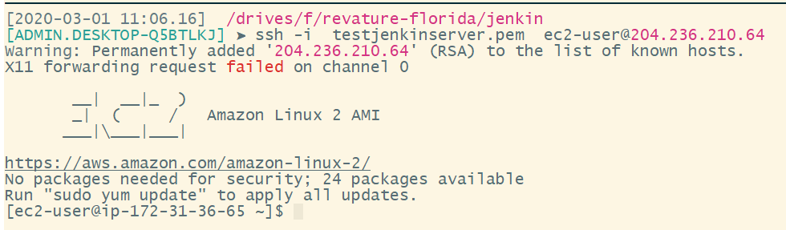
Follow above written Steps
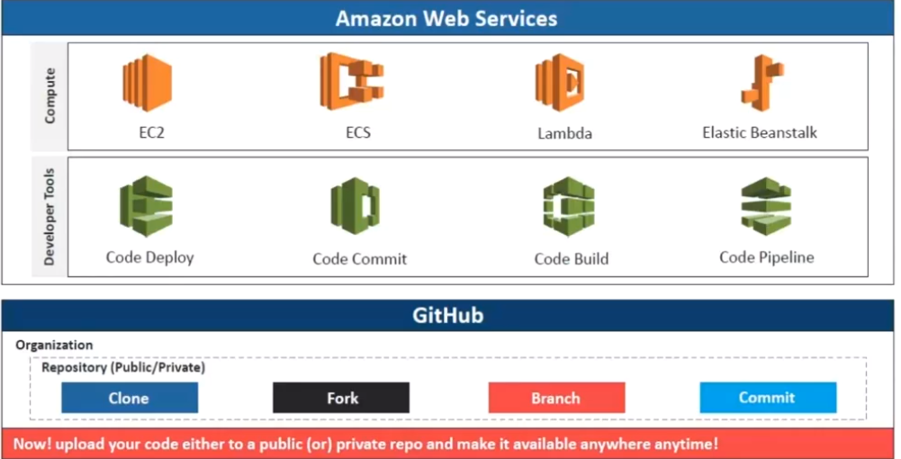
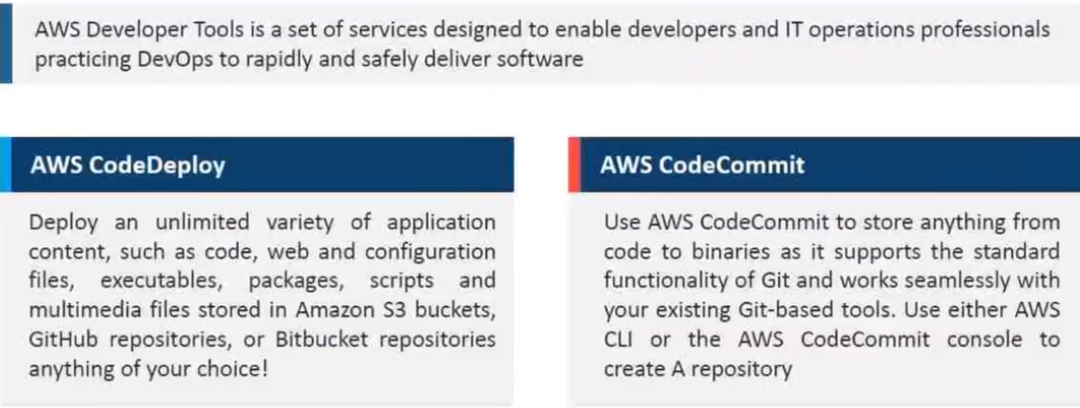

Overview of Jenkins
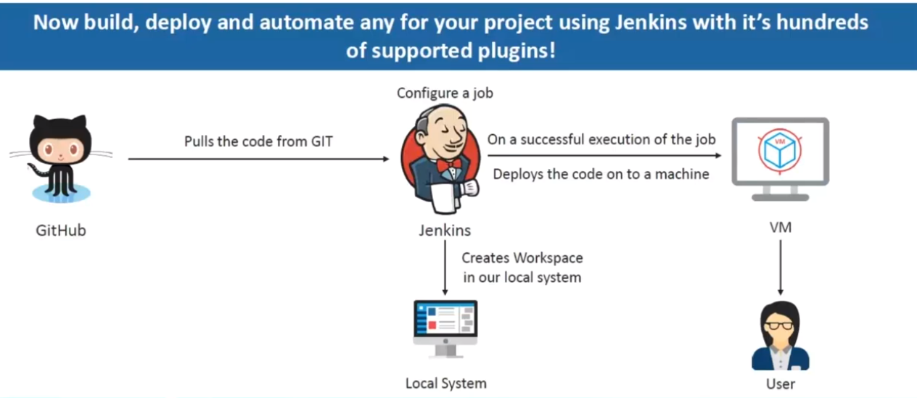

Delivery Pipeline Architecture

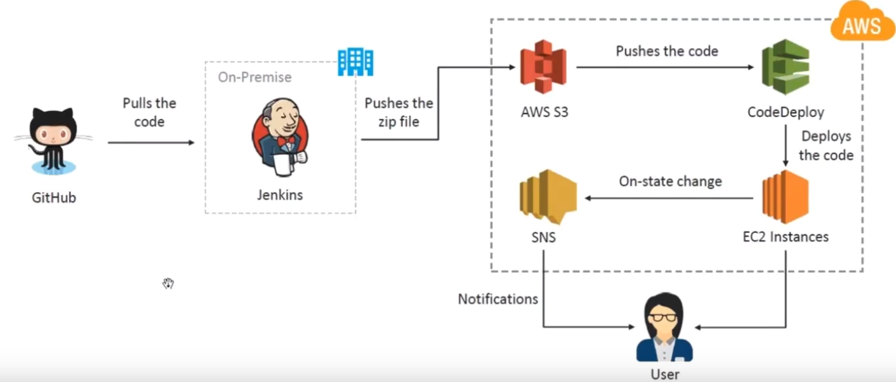
Step 1: Create EC2 instance with http protocol
Step 2: Connect using ssh
Step 3:

Appendix
Lab https://www.youtube.com/watch?v=zEQUuo5nWbo
https://www.youtube.com/watch?v=LFkGtg-ZTko
https://www.youtube.com/watch?v=LFDrDnKPOTg
https://www.youtube.com/watch?v=Z9G5stlXoyg
https://www.youtube.com/watch?v=PQVIuMivAJk
https://www.youtube.com/watch?v=Z3S2gMBUkBo
https://www.youtube.com/watch?v=ieyuZDloaJE

